LEX PROGRAMS
CAPITAL WORD
%{
#include <stdio.h>
#include <stdlib.h>
%}

%%
[A-Z]+[\t\n ] { printf("%s\n", yytext); }
. ;
%%

int yywrap()
{
return 1;
}

int main()
{
printf("Enter the input string:\n");
yylex();
return 0;
}
OUTPUT:
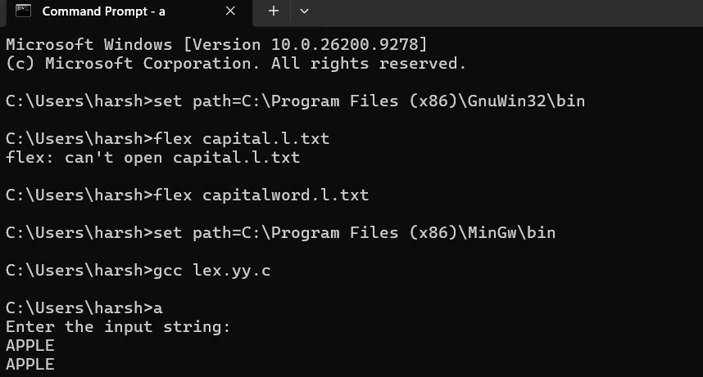
LEX PROGRAM FOR EMAIL VALID OR NOT
%{
#include <stdio.h>
%}

%%

^[a-z0-9._]+@[a-z]+\.(com|in)$ { printf("It is valid\n"); }

.+ { printf("It is not valid\n"); }

%%

int yywrap()
{
return 1;
}

int main()
{
printf("Enter the mail: ");
yylex();
return 0;
}
OUTPUT:
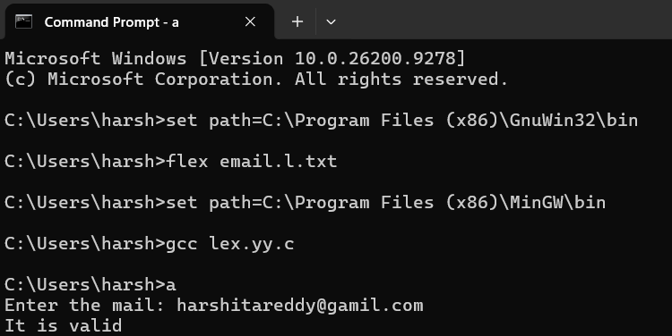
LEX PROGRAM FOR MOBILE NUMBER VALID OR NOT
%{
%}

%%

[6-9][0-9]{9} {printf("\n mobile number valid\n");}
.+ {printf("\n mobile number invalid\n");}

%%
int yywrap(void){}

int main()
{
printf("\n enter the mobile number:");
yylex();
printf("\n");
return 0;
}
Output:
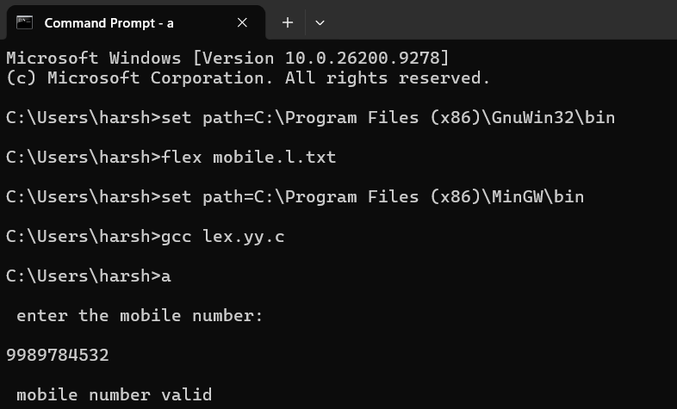
LEX PROGRAM FOR COMMENT \ not
%{
#include<stdio.h>
%}

%%

[/]{2}.* { printf("\n%s is COMMENT", yytext); }
.+ { printf("\n%s is NOT A COMMENT", yytext); }

%%

int yywrap()
{
return 1;
}

int main()
{
while(yylex());
return 0;
}
Output:
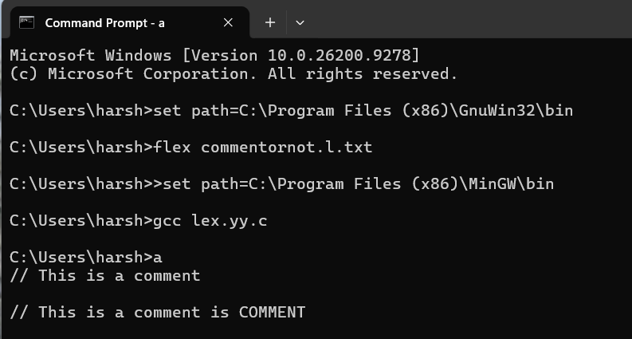
LEX PROGRAM FOR COUNT OF POSITIVE NUMBER AND NEGATIVE NUMBER
%{
#include <stdio.h>
int p=0,n=0;
%}

%%
-[0-9]+ { n++; printf("Negative = %s\n",yytext); }
[0-9]+ { p++; printf("Positive = %s\n",yytext); }
[ \t\n]+ ;
. ;
%%

int yywrap(){ return 1; }

int main()
{
yylex();
printf("\nPositive=%d\nNegative=%d\n",p,n);
}
Output:
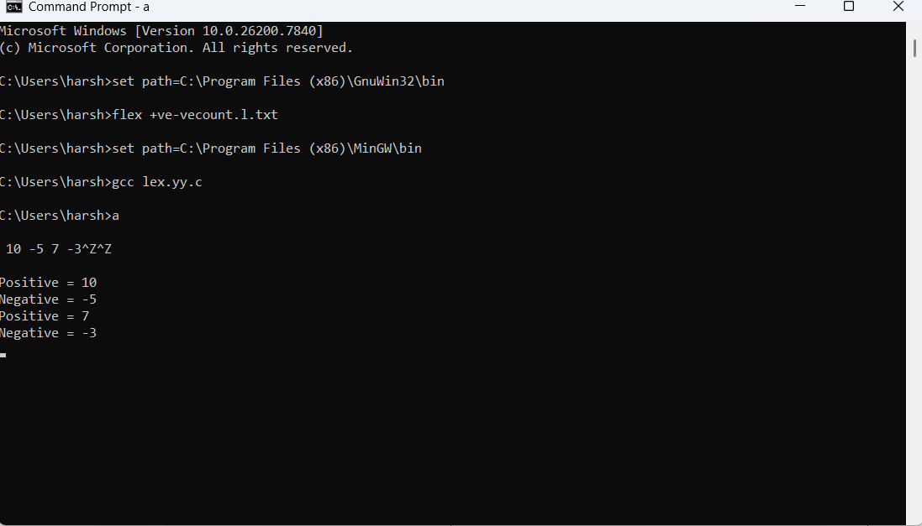
LEX PROGRAM FOR IDENTIFIER OR NOT
%{
#include <stdio.h>
%}

%%

[a-zA-Z][a-zA-Z0-9]* { printf("%s is IDENTIFIER\n", yytext); }
[^a-zA-Z0-9\n]+ ;
\n ;
. { printf("%s is NOT AN IDENTIFIER\n", yytext); }

%%

int yywrap() { return 1; }

int main() {
while(yylex());
return 0;
}
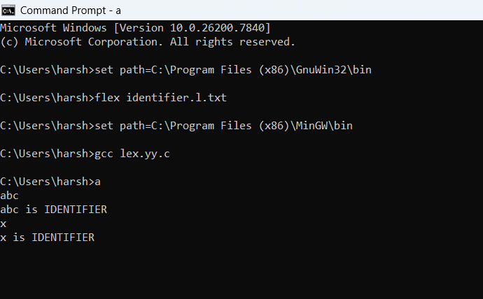
LEX PROGRAM FOR COUNT VOWELS AND CONSONENTS
%{
#include <stdio.h>
int vow_count = 0;
int const_count = 0;
%}

%%

[aeiouAEIOU] { vow_count++; }
[b-df-hj-np-tv-zB-DF-HJ-NP-TV-Z] { const_count++; }

.|\n ;

%%

int yywrap() {
return 1;
}

int main()
{
printf("Enter the string:\n");
yylex();

printf("Number of vowels = %d\n", vow_count);
printf("Number of consonants = %d\n", const_count);

return 0;
}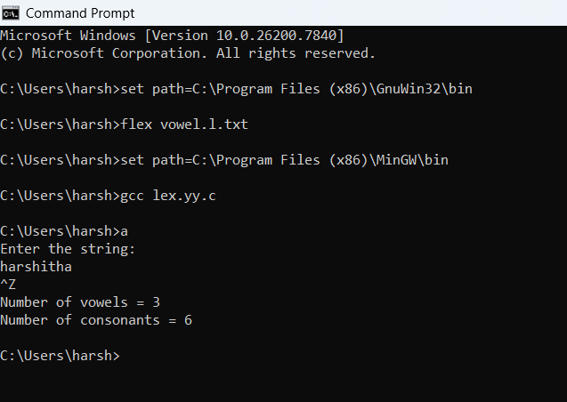
LEX PROGRAM FOR ADD LINE NUMBER
%{
#include <stdio.h>
int ln = 0;
%}

%%

.*\n { ln++; fprintf(yyout,"%d:%s", ln, yytext); }

%%

int yywrap()
{
return 1;
}

int main()
{
yyin = fopen("simple.txt","r");
yyout = fopen("out.txt","w");
yylex();
return 0;
}
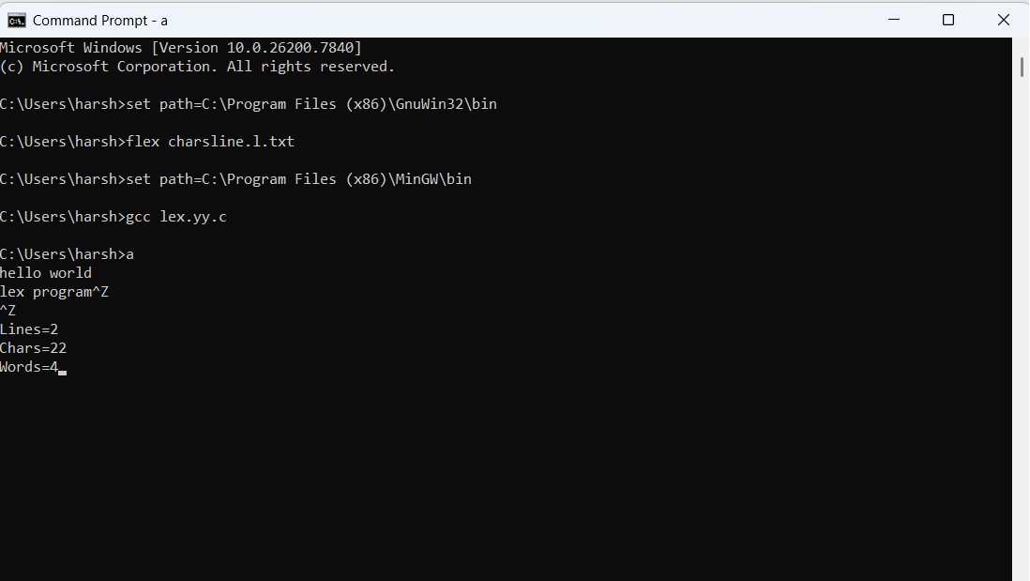
LEX PROGRAM FOR COMMENT OR NOT
%
{
#include<stdio.h>
%}

%%

[/]{2}.* { printf("\n%s is COMMENT", yytext); }
.+ { printf("\n%s is NOT A COMMENT", yytext); }

%%

int yywrap()
{
return 1;
}

int main()
{
while(yylex());
return 0;
}
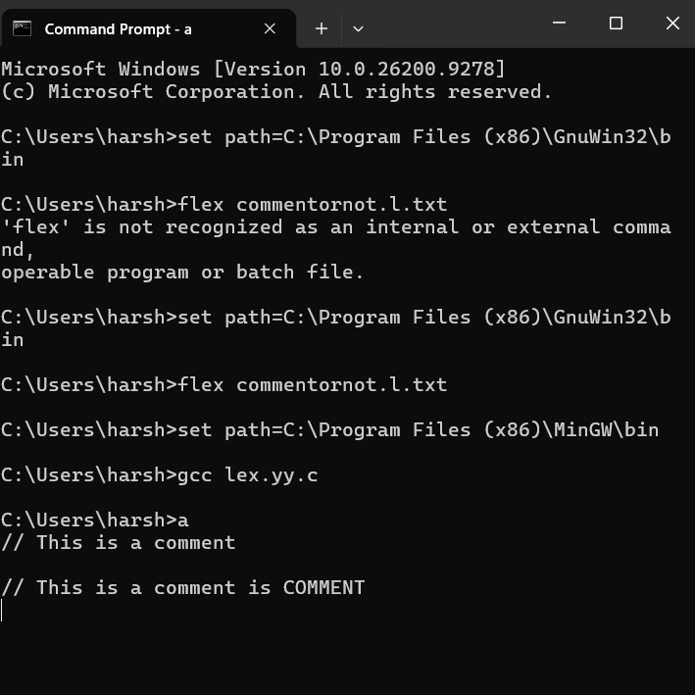
LEX PROGRAM FOR HTML
%
{
#include<stdio.h>
%}
\<[
%%
^>]*\> fprintf(yyout,"%s\n",yytext); .|
\n; %% int yywrap() {
return 1;
}
int main() {
yyin=fopen("sample.html","r");
yyout=fopen("output.txt","w");
yylex();
return 0; }
LEX PROGRAM FOR DIGIT OR NOT
%{
#include<stdio.h>
%}

%%

[0-9]+|[0-9]*\.[0-9]+ { printf("\n%s is DIGIT", yytext); }
.+ { printf("\n%s is NOT A DIGIT",yytext); }

%%

int yywrap()
{
return 1;
}

int main()
{
while(yylex());
return 0;
}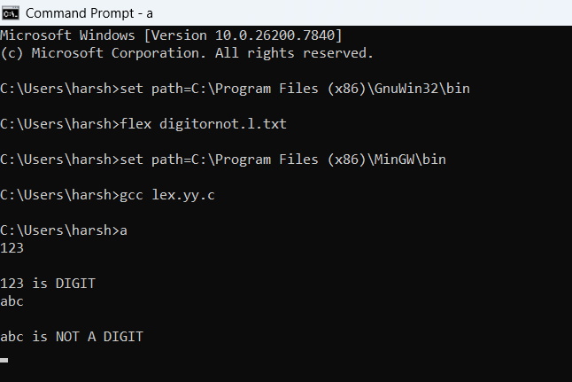
LEX PROGRAM FOR MACROS AND HEADER FILES
%{
#include<stdio.h>
int nmacro=0, nheader=0;
%}

%%

^#define { nmacro++; }
^#include { nheader++; }

%%

int yywrap(void)
{
return 1;
}

int main()
{
yylex();
printf("Number of macros defined = %d\n", nmacro);
printf("Number of header files included = %d\n", nheader);
return 0;
}
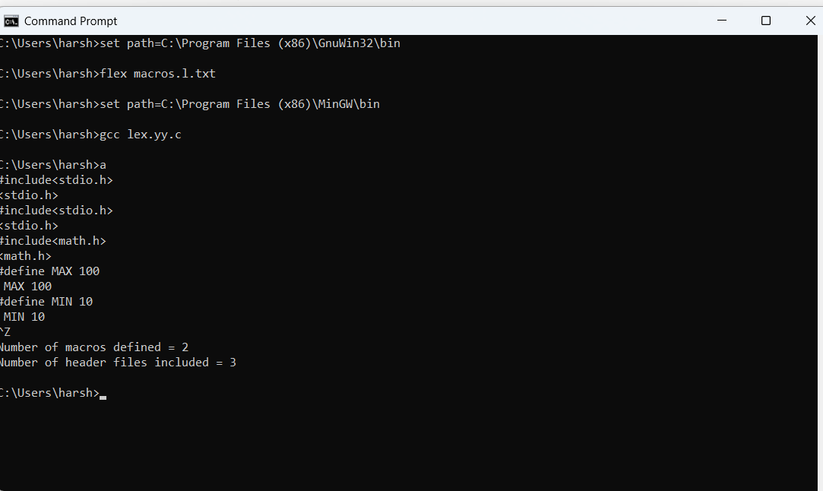
LEX PROGRAM FOR KEYWORDS AND IDENTIFIERS
%{
#include<stdio.h>
%}

%%

if|else|while|int|switch|for|char { printf("%s is KEYWORD\n",yytext); }
[a-zA-Z][a-zA-Z0-9]* { printf("%s is IDENTIFIER\n", yytext); }

%%

int yywrap()
{
return 1;
}

int main()
{
while(yylex());
return 0;
}cc
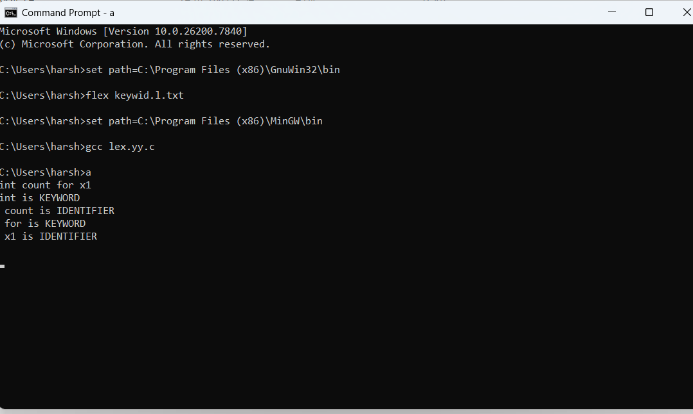
LEX PROGRAM FOR BASIC MATHEMATICAL OPERATIONS
%{
#include<stdio.h>
%}
%%

"="|"+"|"-"|"/"|"*" { printf("valid");}
.+ {printf("invalid");}
%%
int yywrap(){}
int main()
{
printf("enter the input:");
yylex();
return 0;
}
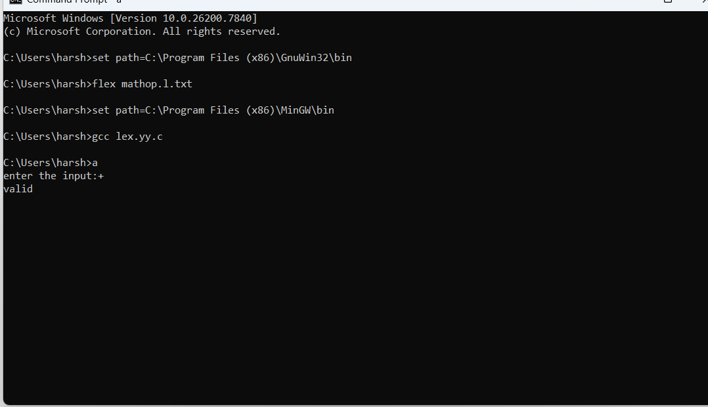
LEX PROGRAM FOR DOB VALID OR NOT
%{
#include<stdio.h>
%}

%%

[0-9][0-9]\/[0-1][0-9]\/[1-2][0-9]{3} { printf("valid");}
.+ { printf("invalid");}
%%

int yywrap(){}

int main()
{
yylex();
}
C

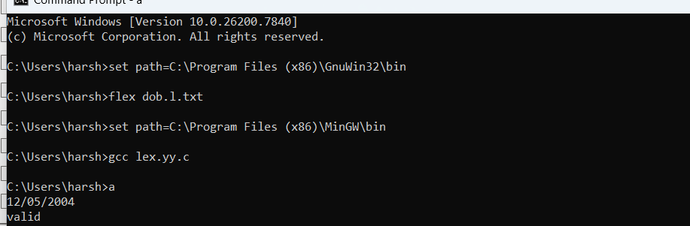
LEX PROGRAM FOR COUNT NO OF TOKENS
%{
#include<stdio.h>
int n = 0;
%}

%%

"while"|"if"|"else"|"int"|"float" { n++; printf("\t keyword : %s\n", yytext); }

[a-zA-Z_][a-zA-Z0-9_]* { n++; printf("\t identifier : %s\n", yytext); }

"<="|"=="|"="|"++"|"-"|"*"|"+" { n++; printf("\t operator : %s\n", yytext); }

[(){}|,;] { n++; printf("\t separator : %s\n", yytext); }

[0-9]*"."[0-9]+ { n++; printf("\t float : %s\n", yytext); }

[0-9]+ { n++; printf("\t integer : %s\n", yytext); }

. ;

%%

int yywrap()
{
return 1;
}

int main()
{
yylex();
printf("\n total no. of token = %d\n", n);
return 0;
}c
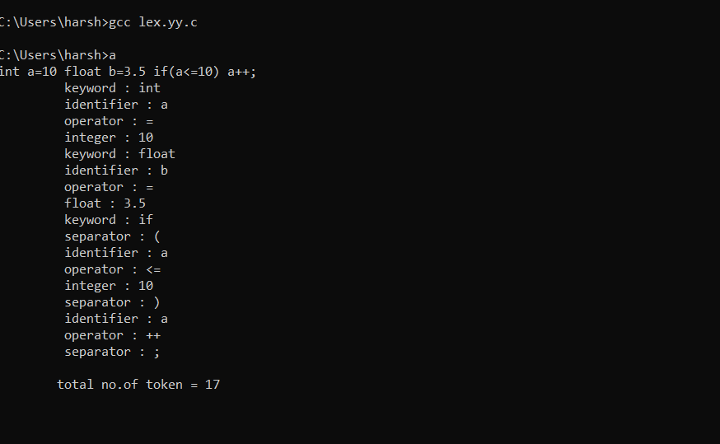
LEX PROGRAM FOR NO.OF CHARS,LINES,WORDS
%{
#include<stdio.h>
int nlines=1,nwords=0,nchars=0;
%}

%%

\n { nlines++; nchars++; }

[^ \n\t]+ { nwords++; nchars += yyleng; }

. { nchars++; }

%%

int yywrap(void)
{
return 1;
}

int main()
{
yylex();
printf("Lines = %d\nChars = %d\nWords = %d\n", nlines, nchars, nwords);
return 0;
}c


LEX PROGRAM TO COUNT WORDS%{
#include<stdio.h>
#include<string.h>
int i = 0;
%}

%%

[a-zA-Z0-9]+ { i++; }

\n { printf("%d\n", i); i = 0; }

%%

int yywrap()
{
return 1;
}

int main()
{
printf("Enter the Sentence : ");
yylex();
return 0;
}
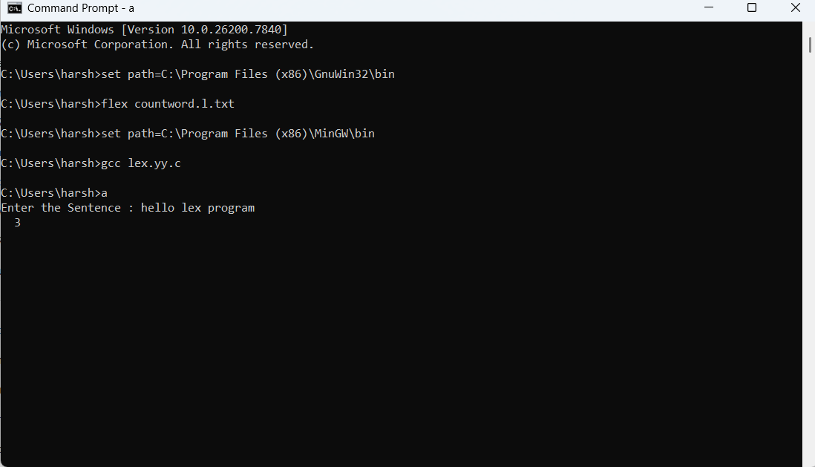
LEX PROGRAM TO COUNT THE FREQUENCY OF THE CODE
%{
#include<stdio.h>
int icount=0,factcount=0;
%}

%%

fact { factcount++; }
i { icount++; }
(.|\n) ;

%%

int yywrap()
{
return 1;
}

int main()
{
yylex();
printf("Count of \"fact\" = %d\nCount of letter 'i' = %d\n", factcount, icount);
return 0;
}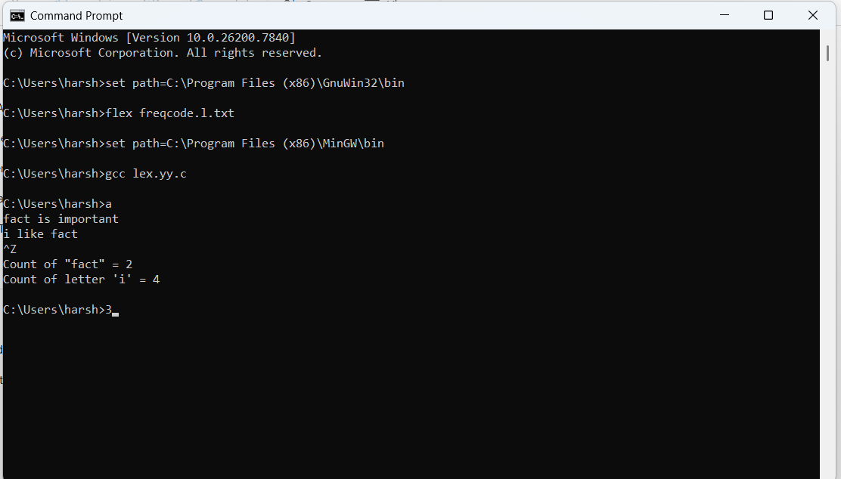
Lex code to find the length of the longest word
%{
#include<stdio.h>
int counter = 0;
%}

%%

[a-zA-Z]+
{
if(yyleng > counter)
{
counter = yyleng;
}
}

%%

int yywrap()
{
return 1;
}

int main()
{
yylex();
printf("largest = %d\n", counter);
return 0;
}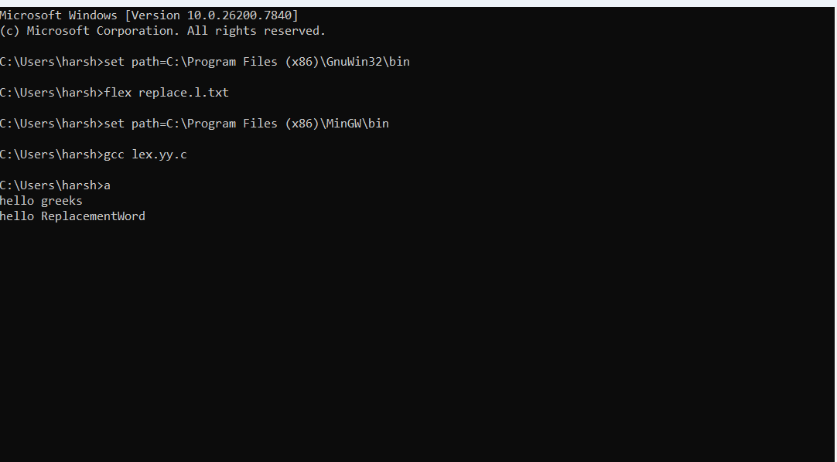
Lex code to replace a word with another word in a file
%{
#include<stdio.h>
%}

%%

"greeks" { printf("ReplacementWord "); }
(.|\n) { putchar(yytext[0]); }

%%

int yywrap()
{
return 1;
}

int main()
{
yylex();
return 0;
}


